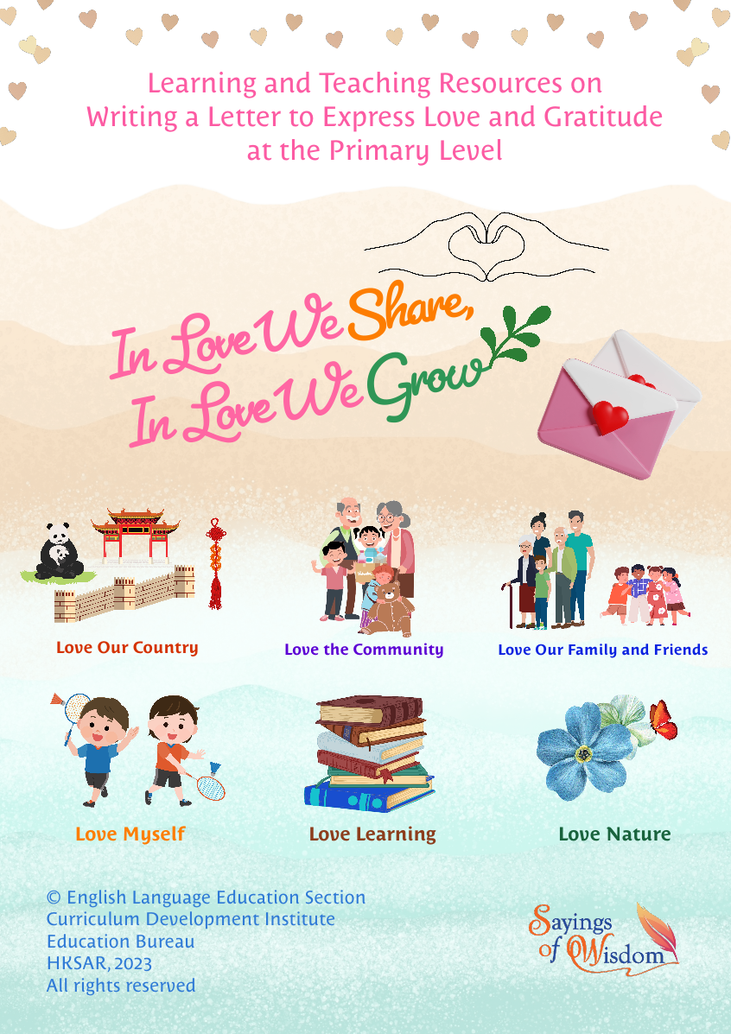

(Blank Page)

English Language Education Section
Curriculum Development Institute
Education Bureau
The Hong Kong Special Administrative Region

12/F, Wu Chung House, 213 Queen’s Road East, Wan Chai, Hong Kong

Published 2023

The copyright of the materials in this resource kit belongs to the Education Bureau of the Hong Kong Special Administrative Region.

Duplication of materials in this resource kit is restricted to non-profit-making educational purposes only. In all cases, proper acknowledgements should be made. Otherwise, all rights are reserved, and no part of these materials may be reproduced, stored in a retrieval system, or transmitted in any form or by any means without the prior permission of the Education Bureau of the Hong Kong Special Administrative Region.

If you have any reason to believe that any information or content of this resource kit may infringe copyright or contain typographical errors, please notify us. Upon receipt of your notification, we will take follow-up action immediately.

© 2023

(Blank Page)

Contents
 |  | Page number
Introduction |  | 1
Learning Task 1 | Fanning the Pillow and Warming the Quilt  (KS1/KS2) | 3
Learning Task 2 | An Interview with Professor Sung Jao Yiu Joseph (KS2) | 27

(Blank Page)
Learning and Teaching Resources on
Writing a Letter to Express Love and Gratitude
at the Primary Level

The Campaign on “Promoting Positive Values and Attitudes through English Sayings of Wisdom” (SOW Campaign) is a territory-wide and cross-curricular initiative that connects English Language education with values education. Building on the success in the past years, the SOW Campaign will continue to feature a variety of student activities to enrich students’ English learning experiences and nurture positive values and attitudes in them. In this connection, two sets of learning and teaching materials are developed to guide students to write a letter to express their love and gratitude to someone or something (e.g. our country, a family member, the environment) and support the learning of the overarching theme, i.e. “In Love We Share, In Love We Grow”, and six sub-themes, i.e. “Love Our Country”, “Love the Community”, “Love Our Family and Friends”, “Love Myself”, “Love Learning” and “Love Nature”.

Aims
The captioned learning and teaching resources aim to support English Language teachers in
- enhancing students’ interest in reading/viewing and developing their language skills;
- promoting positive values and attitudes through guiding students to reflect on the reading/viewing materials and connect their reflections with a SOW; and
- nurturing students’ creativity and developing their writing skills through guiding them to write a letter and create a two-dimensional (2D) artwork to express their love and gratitude to someone or something.

Content
Each set of the learning and teaching materials comprises a reading/multimodal text about a famous story/a fantastic person and suggested reading/viewing as well as writing activities with teaching steps to develop students’ language skills, cultivate positive values and attitudes, and nurture their creativity. The writing task provides opportunities for students to express their love and gratitude to someone or something with a SOW that echoes the above-mentioned theme and/or sub-theme(s).

Learning Task 1 – Fanning the Pillow and Warming the Quilt (KS1/KS2)
Students learn the SOW “Love begins by taking care of the closest ones – the ones at home.” and understand the positive values and attitudes behind (e.g. to love our family and friends) through reading the story “Fanning the Pillow and Warming the Quilt”. In the writing part, a sample letter (i.e. a son writing to his beloved father) is provided to help students understand the text features. Elements of the creative use of English (e.g. using similes to describe people more vividly) and a graphic organiser are introduced to support students in writing their letters.
Learning Task 2 – An Interview with Professor Sung Jao Yiu Joseph (KS2)
Students learn the SOW “The best way to find yourself is to lose yourself in the service of others.” and understand the positive values and attitudes behind (e.g. to love our community) through viewing “An Interview with Professor Sung Jao Yiu Joseph” in the “Fantastic People Videos” series
(https://emm.edcity.hk/playlist/1_hea30nj2/1_gjbkgroh). In the writing part, a sample letter (i.e. a primary school graduate writing to her alma mater) is provided to help students understand the text features. Elements of the creative use of English (e.g. using literary devices to describe people and feelings) and a graphic organiser are introduced to support students in writing their letters.
“Fantastic People Videos”

In both Learning Tasks 1 and 2, students are required to create a 2D artwork to enhance conveyance of meaning and visual representation of the letter. The self-assessment checklist at the end helps them assess and improve their writing as well as their creative artwork.

How can the resources be used?
The resources consist of learning tasks and teaching ideas on how to promote positive values and attitudes among students with SOW in the primary English classroom. Teachers are encouraged to adopt and/or adapt the learning materials and teaching ideas to cater for students’ needs, interests and abilities.

Learning Task 1
Fanning the Pillow and Warming the Quilt

Theme
In Love We Share, In Love We Grow – Love Our Family and Friends

Suggested Key Stage
KS1/KS2

Task Description
Students read the story “Fanning the Pillow and Warming the Quilt”. Teachers guide students to understand the story, analyse the main character, Huang Xiang, discuss the moral message, and connect their reflections on Huang Xiang’s story with a saying of wisdom (SOW). After that, students read a letter written by Huang Xiang to his father to learn how to get readers’ attention and describe people more vividly. Students then connect their personal experiences with a SOW that echoes the overarching theme, i.e. “In Love We Share, In Love We Grow”, and/or the sub-themes “Love Our Country”, “Love the Community”, “Love Our Family and Friends”, “Love Myself”, “Love Learning” and “Love Nature”. Finally, they write a letter and create a two-dimensional (2D) artwork to express their love and gratitude to someone or something.

Learning Objectives
Content
- To understand the content of the story “Fanning the Pillow and Warming the Quilt”
- To analyse the character traits of the main character, Huang Xiang
- To connect a related SOW with Huang Xiang’s story
- To develop positive values and attitudes

Language
- To practise reading skills (e.g. locating specific information and making inferences)
- To learn about adjectives to describe the personality of a character
- To introduce the features of a letter to express our love and gratitude to someone or something and the creative use of English (e.g. superlative adjectives and similes) to get readers’ attention and describe people more vividly
- To practise writing skills (e.g. planning and organising information using graphic organisers)

Suggested Learning Activities
Pre-reading Activity
- Brainstorm with students how they show love and care to their family member(s).
- Among all the family members, who is/are the one(s) you like the most? Why?
- Share one memorable experience with the family member(s) using WH-questions, e.g.
- What happened to you and him/her/them?
- What did you do together?
- How did you feel about the experience?
- How do you show your love and care to him/her/them?
- Tell students that they are going to read a story about Huang Xiang. Show them a picture of Huang Xiang fanning the pillow and the bed (e.g. the picture below the reading text). Ask them the following questions:
- What did Huang Xiang do on a hot summer night? Why did he do that?
- If you were Huang Xiang, would you do the same? Why?
- Pre-teach the vocabulary to help students understand the reading text and guide them to complete Worksheet 1.
While-reading Activity
- Introduce adjectives to describe the personality of Huang Xiang with reference to what he said and have students complete Part 1 of Worksheet 2.
- Guide students to skim and scan the reading text by asking questions and have them complete the multiple-choice questions in Part 2 of Worksheet 2.
Post-reading Activity and Values Education
- Engage students in discussing the good behaviour of Huang Xiang and the moral of the story.
- Guide students to think about the types of love as shown from Huang Xiang’s behaviour and have them complete Part 1 of Worksheet 3.
- Introduce the meaning of “Sayings of Wisdom (SOW)” and four selected SOW to students, and have them complete Part 2 of Worksheet 3. Have students work in groups and tell their groupmates the SOW they have chosen to describe Huang Xiang.
“SOW in Love” Letter Writing Competition
- Provide a context for students to write a letter to express love and gratitude to someone or something with a SOW in Part 1 of Worksheet 4 and introduce the overarching theme and sub-themes of the “SOW in Love” Letter Writing Competition to students.
- Introduce the text features of the letter through finding out the main ideas in each part of a sample text in Part 2 of Worksheet 4.
- Guide students to understand the creative use of English to get readers’ attention and describe people more vividly, and have them complete Part 3 of Worksheet 4.
- Introduce elements of the creative use of English (i.e. superlative adjectives, similes and dialogue) to students and have them complete Parts 4a, 4b and 4c of Worksheet 4.
- Provide a graphic organiser for students to construct their letters in Part 5a of Worksheet 4, have students write their letters in Part 5b and design a two-dimensional (2D) artwork to enhance conveyance of meaning and visual representation of their letters in Part 5c.
- Guide students to conduct self-assessment by referring to the self-assessment checklist in Part 5d.
(Reading Text)  Fanning the Pillow and Warming the Quilt  In the Eastern Han Dynasty*, a boy named Huang Xiang lived with his father in a hut in a small village. His mother passed away when he was nine. His father worked very hard from day to night to earn a living. One day, when Huang Xiang was washing the clothes near a river, he thought of his mother suddenly.  5  “Mum, you worked so hard in your entire life and taught me to be a good boy. You were one of the kindest persons in the world! I will never forget you. I promise I will try my best to take care of Dad,” Huang Xiang said to himself.  10  In order to give his father more time to rest, Huang Xiang helped him with the housework. “Dad works tirelessly for the family. I need to help him gather firewood for cooking, carry water from the well and prepare the meals,” thought Huang Xiang. “I should not play too much. I have to spend my time on studying so that I can provide Dad with a better living condition in the future.”  15  During summer, there were a lot of mosquitoes near Huang Xiang’s hut and the weather was very hot. Huang Xiang used a fan to drive away the mosquitoes and cool his father’s pillow and bed every night. When it was cold in winter, Huang Xiang prepared hot water and food to keep his father warm. Before his father went to sleep, he used his body to warm the quilt and the mattress.  20  “My son, you must have done something to make the bed cool in summer and warm in winter. What is that?” asked Huang Xiang’s father.  * The Eastern Han Dynasty refers to a dynasty in ancient Chinese history that ruled from 25 AD to 220 AD.  “Dad, I don’t want you to suffer from mosquito bites, so I fan your bed before letting you sleep in it during summer. While in winter, the weather is freezing. I am worried that you may catch a cold easily, so I crawl into your bed to warm the quilt and mattress beforehand,” replied Huang Xiang. His father’s tears started rolling down his cheeks after hearing his son’s reply.  30  “My dear boy, I am so lucky to have you as my son. Remember, you need to study hard because you will be able to help more people if you become a good official when you grow up,” said Huang Xiang’s father as he hugged his warm-hearted son. The story about Huang Xiang’s acts of filial piety soon spread throughout the entire village. All the people praised him as the role model.  35  Remembering his father’s words, Huang Xiang put his utmost effort into his studies. “I have to read many books to learn from the past experiences and broaden my horizons.” Huang Xiang finally became an important official when he grew up, and he excelled in both military and administrative affairs. While he was serving as an official of the State of Wei, a severe flood happened in the country. Huang Xiang donated his savings to help the people and everyone highly admired him for his kindness.  40 | Line
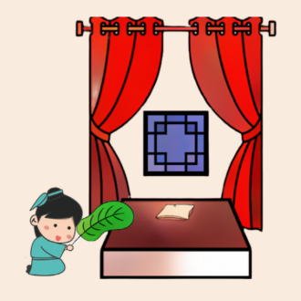
25

Pre-reading Activity
(Worksheet 1)
Part 1: Match the pictures with the words given.
1.
3.
 | 2. | 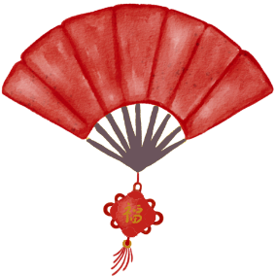 | 4.

a fan | a hut | firewood | a quilt

Part 2: Fill in each blank with the best word given in Part 1.

1. Huang Xiang lived in a ______________ with his father when he was young.

2. Huang Xiang helped his father collect ________________ for cooking.

- Huang Xiang used a ______________ to cool his father’s bed during summer.

- Huang Xiang warmed his father’s ______________ in winter to prevent him from catching a cold easily.

While-reading Activity
Can
(Worksheet 2)

What are character traits?
Character traits refer to characters’ personality or qualities that make them who they are. We can determine character traits by looking at what a character thinks, says or how he/she feels.

Part 1: Read what Huang Xiang thought or said. What kind of person was he? Choose the best adjective of personality and write the letter in each box below.

A.  Disciplined | B.  Polite | C.  Helpful | D.  Caring
I should not play too much. I have to spend my time on studying so that I can provide Dad with a better living condition in the future.

2.
1.

I need to help him gather firewood for cooking, carry water from the well and prepare the meals.

Dad, I don’t want you to suffer from mosquito bites, so I fan your bed before letting you sleep in it during summer.
3.

Part 2: Read the story “Fanning the Pillow and Warming the Quilt” on pp.5-6 again. Choose the best answer by circling the correct letter.

- When was Huang Xiang born? He was born in the __________.
- Zhou Dynasty
- Eastern Han Dynasty
- Western Han Dynasty
- Song Dynasty

- What did Huang Xiang do near a river? He ________.
(A) carried water from the river
(B) worshipped his late mother
(C) washed the clothes
(D) collected firewood

- Why did Huang Xiang help his father with the housework?
Huang Xiang would like to __________.
(A) cook delicious meals for his father
(B) improve the living condition in the future
(C) help more people
(D) give his father more time to rest

- Read line 29. What does “tears started rolling down his cheeks” mean?
Huang Xiang’s father was _______________ his son’s behaviour.
(A) moved by
(B) anxious about
(C) interested in
(D) angry about

- What did Huang Xiang’s father want him to do in the future?
Huang Xiang’s father wanted him to be a ____________ in the future.
(A) role model
(B) good official
(C) helpful villager
(D) warm-hearted son

- Why did people respect Huang Xiang when he was an official of the State of Wei?
(A) He kept all his savings for himself.
(B) He grew vegetables to feed the people.
(C) He cooked meals for all the people.
(D) He gave away his money to help the people.

Post-reading Activity
(Worksheet 3)

Part 1: Huang Xiang showed his love by doing many good things to his father and other people. What types of love are they? Read the description below. Choose the best answer and write the letter in each heart . Each option can be used more than once.
A.  Love Myself | B.  Love the Community
C.  Love Learning | D.  Love Our Family and Friends

Huang Xiang read many books instead of going out to play.
2.
1.

Huang Xiang prepared food for his father.

Huang Xiang donated his savings to help the people in the village during a severe flood.
Huang Xiang fanned his father’s bed in summer and warmed the quilt in winter to provide him with a comfortable sleeping place.
4.
3.

Part 2: An Introduction to Sayings of Wisdom (SOW)
A saying of wisdom (SOW) can be a proverb/quote or a line from a text. Study the following selected SOW and match them with the relevant type of love. Which SOW would you use to describe Huang Xiang’s good behaviour? Work in groups and tell your groupmates about it.

 | SOW |  |  |  |  |  |  |  | Types of Love
1. | The first wealth is health.  (Ralph Waldo Emerson) |  |  |  |  |  |  | Love the Community
2. | No one has ever become poor by giving.  (Anne Frank) |  |  |  |  |  |  | Love Learning
3. | I have no special talent. I am only passionately curious.  (Albert Einstein) |  |  |  |  |  |  | Love Myself
4. | Walking with a friend in the dark is better than walking alone in the light.  (Helen Keller) |  |  |  |  |  |  | Love Our Family and Friends
The “SOW in Love” Letter Writing Competition
(Worksheet 4)
Context:
You would like to enter the “SOW in Love” Letter Writing Competition to express your love and gratitude to someone or something in around 100 to 130 words. You need to write a letter with a SOW of your choice that echoes the overarching theme “In Love We Share, In Love We Grow” and/or the six sub-themes below. Then, you have to create a two-dimensional (2D) artwork for the letter.

Part 1: Understand the overarching theme and the sub-themes.

In Love We Share, In Love We Grow

Love Our Country
Embracing our national identity, affection for hometown, appreciation of Chinese culture and heritage

Love the Community
Fostering a harmonious and inclusive society, caring for your school and neighbours, respecting diversity

Love Our Family and Friends
Filial piety and reverence for ancestors, responsibility and commitment to the family, friendship

Love Learning
Being inquisitive and reflective, a drive to apply and experiment with knowledge, lifelong learning
Love Myself
Personal growth, self-management, leading a healthy lifestyle

Love Nature
Biodiversity conservation, animal protection, green living

Can you suggest other things that we can do to express our love in different dimensions?
Part 2: Analyse the text features of a letter to someone to express our love and gratitude.
Huang Xiang has written a letter to his father. Read his letter carefully. Identify the key features and fill in each box with a correct letter.

- Saying of Wisdom (SOW) | - Greeting | - Closing and writer’s name
- Purpose of the letter and a general description of the person | - A memorable experience | - Reflections that connect the SOW and the experience

Dear Dad,

I want to tell you how much I love you. You are the greatest dad in the world!

I remember once I hurt my foot. I cried and you immediately ran to find some herbs to heal my injury. You comforted me and said, “Don’t worry. You will get well soon. Be careful next time.” I was sorry for being careless.

As the saying of wisdom goes, “Love begins by taking care of the closet ones – the ones at home.” You show that to me every day. You are my superhero and my best friend. You take great care of me. Your love for me is as deep as the sea. I promise to be a good man like you when I grow up.

Love,
Heung

Part 3: Analyse the language used in the letter.
Study Huang Xiang’s letter again. Follow the instructions to complete the activities below.
Dear Dad,

I want to tell you how much I love you. You are the greatest dad in the world!

I remember once I hurt my foot. I cried and you immediately ran to find some herbs to heal my injury. You comforted me and said, “Don’t worry. You will get well soon. Be careful next time.” I was sorry for being careless.

As the saying of wisdom goes, “Love begins by taking care of the closet ones – the ones at home.” You show that to me every day. You are my superhero and my best friend. You take great care of me. Your love for me is as deep as the sea. I promise to be a good man like you when I grow up.

Love,
Heung

Circle the words that describe Huang Xiang’s father in paragraph 1.
1.
3.
2.
1.
Underline the sentence that talks about the love of Huang Xiang’s father to his son in paragraph 3.

2.

- Read what Huang Xiang’s father said in paragraph 2. What do you think about him?
3.
_______________________________________________________________

_______________________________________________________________

Part 4: (a) Understand the language used - Superlative adjectives.
The superlative adjective “the greatest” is used in the letter to get readers’ attention and highlight the uniqueness of Huang Xiang’s father.
Can

What is a superlative adjective?
A superlative adjective is an adjective used to describe something as being of the highest degree of a quality.
We can use superlative adjectives to get readers’ attention by highlighting the uniqueness of a person/an animal, e.g. the bravest, the most caring.
When we use superlative adjectives, we need to add “the” and observe the following rules:
- Adjectives with one syllable, e.g. short – shorter – the shortest
- Adjectives with one/two syllable(s) and ending in “y”, e.g. easy – easier – the easiest
- Adjectives with two or more syllables, e.g. exciting – more exciting – the most exciting
- Irregular adjectives, e.g. good – better – the best

- Read the following superlative adjectives carefully. Circle the words that can be used to describe people with positive meanings.

the prettiest the kindest the dirtiest the cutest
the most selfish the most adorable the greediest
the most generous the most talented

- You are going to write about someone (e.g. a character in a short story) or something (e.g. your school) you love. Think of a positive superlative adjective or choose one from the above to describe him/her/it, and then write a sentence below.

Part 4: (b) Understand the language used - Similes.
The simile “as deep as the sea” is used in the letter to show readers the love of Huang Xiang’s father towards his son.
Can

What is a simile?
A simile is an expression comparing one thing with another, using the words “as” or “like”.
We can use similes to make the description more interesting, vivid and creative,
e.g. “My mother is as gentle as a lamb.”
(She is pleasant and calm.)
e.g. “The clouds are as big as an elephant.”
(The clouds are very large.)
e.g. “Tom always comes up with a clever solution to solve a challenging problem. He is as wise as an owl.
(Tom is very clever.)

- The similes below are grouped according to their nature. Choose the best answer and write the letter in the brackets to complete the similes.
- a feather | - a lark | - old boots | - a giraffe

Nature | Meaning | Simile
Appearance | very tall | - as tall as ( )
Weight | not heavy | - as light as ( )
Feelings | very happy | - as happy as ( )
Personality | very strong | - as tough as ( )

- Think of a simile or choose one from the above to describe someone or something you love, and then write a sentence below.

Part 4: (c) Understand the language used - Dialogue.
A dialogue from Huang Xiang’s father is quoted in the letter to show readers his kindness and care towards his son.
Can

What is a dialogue?
A dialogue is a written conversation between two or more people. We can use dialogue to show people’s thoughts, emotions or personality. When we use dialogue, we need to observe the following rules:
- use quotation marks before and after the speaker’s exact words, e.g. “Can we have more vegetables for dinner?”
- use a comma to set off the speaker’s tag (e.g. he said) from the beginning of a quotation, e.g. Ray said, “Come on, Tom.”
- put a comma before the closing quotation mark when the speaker’s tag follows the quotation, e.g. “English is my favourite subject,” she said.
- put a question mark or an exclamation mark inside the quotation marks, e.g. “When will he be back?” asked Tom.

- Revise the following dialogue by adding quotation marks or other punctuation marks where necessary.

 | It is time to go to bed, Mother said.
 | “I wish to have a red teddy bear” replied Jack.
3. | Tom asked “When will the movie start?”

- Think of a memorable experience with someone or something you love. Write about what you said to him/her/it below.

Part 5: (a) Think of someone (e.g. a character in a short story, your future self) or something (e.g. your school, the environment) you would like to write about. Based on the details in Parts 1- 4, organise your ideas using the graphic organiser below.
Continue your writing on p. 20
Parts of the letter | Details
Greeting  - Who do you write the letter to? | Dear _____________________________,
Purpose of the letter  - Why do you write the letter?  - What do you think about the person or the thing you love?  Use the simple present tense to describe facts about the person or the thing you love.  Use superlative adjectives to get readers’ attention and highlight the uniqueness of the person or the thing you love. | __________________________________  __________________________________  __________________________________  __________________________________  __________________________________  __________________________________  __________________________________  __________________________________
Writer’s experience  - What was the most memorable experience you had with the person or the thing you love?  - What did you say to each other?  - What did you think about the experience?  Use the simple past tense to describe the experience.  Use dialogue to show your thoughts or emotions.  Use similes to describe the person or the thing you love more vividly, e.g. personality or appearance. | __________________________________  __________________________________  __________________________________  __________________________________  __________________________________  __________________________________  __________________________________  __________________________________  __________________________________  __________________________________  __________________________________  __________________________________  __________________________________
Sayings of Wisdom (SOW)  - What is the SOW that connects with your experience?  - Which sub-theme does it belong to?  Use the simple present tense to describe the SOW. | __________________________________  __________________________________  __________________________________  __________________________________  __________________________________  __________________________________
Reflections that connect the SOW and the experience  - How are your experience and reflections connected with the SOW?  - What do you learn from the person or the thing you love?  Use the simple present tense to describe the connection between the SOW and the experience, and your reflections. | __________________________________  __________________________________  __________________________________  __________________________________  __________________________________  __________________________________  __________________________________  __________________________________  __________________________________  __________________________________
Closing and writer’s name  Use “Best”, “Cheers” or “Love” to end the letter | __________________________________  __________________________________  __________________________________  __________________________________
Part 5: (b) Use the ideas in the graphic organiser on pp.19-20 to write a letter to express your love and gratitude to someone or something with a SOW of your choice in around 100-130 words.

Part 5: (c) Create a 2D artwork to enhance conveyance of meaning and visual
representation of the letter.

Part 5: (d) Check your writing with the self-assessment checklist below.
Self-assessment Checklist
Assessment criteria |  | My performance  (Colour the smileys)
Content
1. | I can give a proper greeting at the beginning and a closing at the end of the letter.
2. | I can write about a memorable experience I had with the person or the thing I love.
3. | I can share a SOW and connect it with my reflections.
Language
4. | I can use the simple present tense to describe facts.
5. | I can use the simple past tense to describe the memorable experience with the person or the thing I love.
6. | I can use superlative adjectives to get readers’ attention and highlight the uniqueness of the person and the thing I love.
7. | I can use dialogue to show thoughts, emotions or personality of the person or the thing I love.
8. | I can use similes to describe the person or the thing I love, e.g. personality or appearance.
Organisation
9. | I can put ideas into appropriate paragraphs.
Design of the letter
10. | I can create a 2D artwork to enhance conveyance of meaning and visual representation of the letter.
Suggested Answers
(Worksheet 1)
Pre-reading Activity
Part 1
2.
4.
1.
3.
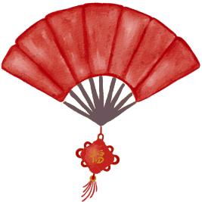

a fan | a hut | firewood | a quilt

Part 2
- hut 2. firewood 3. fan 4. quilt
(Worksheet 2)
While-reading Activity

Part 1
1. C 2. A 3. D

Part 2
1. B 2. C 3. D 4. A 5. B 6. D
(Worksheet 3)
Post-reading Activity

Part 1
1. D 2. A, C 3. D 4. B

Part 2
 | SOW | Types of Love
 | The first wealth is health. (Ralph Waldo Emerson) | Love Myself
 | No one has ever become poor by giving. (Anne Frank) | Love the Community
 | I have no special talent. I am only passionately curious. (Albert Einstein) | Love Learning
 | Walking with a friend in the dark is better than walking alone in the light. (Helen Keller) | Love Our Family and Friends
The “SOW in Love” Letter Writing Competition
(Worksheet 4)
Part 2
C

Dear Dad,

I want to tell you how much I love you. You are the greatest dad in the world!

I remember once I hurt my foot. I cried and you immediately ran to find some herb to heal my injury. You comforted me and said, “Don’t worry. You will get well soon. Be careful next time.” I was sorry for being careless.

As the saying of wisdom goes, “Love begins by taking care of the closet ones – the ones at home.” You show that to me every day. You are my superhero and best friend. You take great care of me. Your love for me is as deep as the sea. I promise to be a good man like you when I grow up.

Love,
Heung

A

D

B

E
F

Part 3
1. the greatest
2. Your love for me is as deep as the sea.
3. He is kind and caring (because he comforted his son). (Accept any reasonable answers.)

Part 4
(a)
(i) the prettiest, the kindest, the cutest, the most adorable, the most generous, the most talented
(ii) My mother is the kindest person in the family. (Accept any reasonable answers.)

(b)
(i)
- D 2. A 3. B 4. C
(ii)
My mother loves to smile. She is always as happy as a lark. (Accept any reasonable answers.)

(c)
(i)
1. “It is time to go to bed,” Mother said.
2. “I wish to have a red teddy bear,” replied Jack.
3. Tom asked, “When will the movie start?”
(ii)
“My son, don’t give up easily. Stay positive. You can succeed if you try,” said Mum. (Accept any reasonable answers.)

Learning Task 2
An Interview with Professor Sung Jao Yiu Joseph

Theme
In Love We Share, In Love We Grow – Love Learning and Love the Community

Suggested Key Stage
KS2

Task Description
Students watch an interview with Professor Sung Jao Yiu Joseph and learn about his challenges and contributions to the advancement of medical sciences and academic development. Teachers guide students to understand Professor Sung’s positive attitudes and connect their reflections on Professor Sung’s experiences with a saying of wisdom (SOW). After that, students explore elements of the creative use of English to describe people and feelings more vividly. They learn about the text features of a letter written by a primary school graduate to express her love and gratitude to her alma mater. They also learn how to connect personal experiences and reflections with a SOW that echoes the overarching theme, i.e. “In Love We Share, In Love We Grow”, and/or the sub-themes “Love Our Country”, “Love the Community”, “Love Our Family and Friends”, “Love Myself”, “Love Learning” and “Love Nature”. Then, they write a letter and create a two-dimensional (2D) artwork to express their love and gratitude to someone or something.

Learning Objectives
Content
- To understand the success story of Professor Sung
- To analyse the personality traits of Professor Sung
- To connect a related SOW with Professor Sung’s experiences
- To develop positive values and attitudes

Language
- To practise viewing skills (e.g. making predictions about the challenges Professor Sung faced, completing Professor Sung’s profile by locating specific information)
- To introduce the text features of a letter from a primary school graduate to her alma mater and explore the creative use of English (e.g. literary devices) to describe people and feelings more vividly
- To practise writing skills (e.g. planning and organising information using graphic organisers)

Suggested Learning Activities
Pre-viewing Activity
- Refer students to Worksheet 1 and draw their attention to the pictures, which depict two scenes of the “Fantastic People” video “Professor Sung Jao Yiu Joseph”.
- Guide students to make predictions about Professor Sung’s jobs and his challenges by drawing their attention to the visual clues captured in the pictures. Discuss with students their predictions.
While-viewing Activity
- Watch an interview with Professor Sung and guide students to complete a profile in Part 1 of Worksheet 2.
- Have students complete the multiple-choice questions in Part 2 of Worksheet 2 to check their understanding of the video.
Post-viewing Activity and Values Education
- Engage students in discussing the personality traits of Professor Sung through two memorable moments. Encourage them to present their ideas with 1-2 adjectives which best describe(s) Professor Sung, elaborate their ideas with clues from the interview, and complete Part 1a of Worksheet 3. Guide students to think about the types of love as shown from the two moments and have them complete Part 1b.
- Introduce the meaning of “Sayings of Wisdom (SOW)” and six selected SOW in Part 2 of Worksheet 3 to students. Have students work in groups and view the segment about how Professor Sung fought against SARS in Hong Kong in 2003 again. Ask them to discuss Professor Sung’s challenges and his positive attitudes towards those challenges with the support of the guiding questions in Part 3. Then, have students choose one of the SOW in Part 2 to describe how Professor Sung fought against SARS.
- Have students discuss what they have learnt from Professor Sung, think of what they would like to say to Professor Sung and complete Part 3 of Worksheet 3.
“SOW in Love” Letter Writing Competition
- Provide a context for students to write a letter in Part 1 of Worksheet 4 and introduce the overarching theme and sub-themes of the “SOW in Love” Letter Writing Competition to students.
- Introduce to students elements of the creative use of English (e.g. literary devices and the “Showing not Telling” technique) to describe people and feelings more vividly in Part 2 of Worksheet 4.
- Introduce the text features of a letter from a primary school graduate to her alma mater and the language used in the letter to students in Part 3 of Worksheet 4.
- Provide a graphic organiser for students to construct their letters in Part 4a of Worksheet 4.
- Have students write a letter to express their love and gratitude to someone or something with a SOW that echoes the overarching theme and/or the sub-theme(s) in Part 4b and design a two-dimensional (2D) artwork to enhance conveyance of meaning and visual representation of their letter in Part 4c.
- Guide students to conduct self-assessment by referring to the self-assessment checklist in Part 4d.

Pre-viewing Activity
(Worksheet 1)
Making predictions about Professor Sung Jao Yiu Joseph
Have you ever heard of Professor Sung? Study the pictures below, which depict two scenes of the “Fantastic People” video “Professor Sung Jao Yiu Joseph”. Write down your thoughts in Boxes (a) – (d).
- Why did Professor Sung want to be a doctor?
- What did Professor Sung usually do for his patients?

- Apart from being a doctor, what else did Professor Sung do? Did he enjoy his jobs? Why?
- What was Professor Sung’s biggest challenge in his career as a doctor?

While-viewing Activity
(Worksheet 2)
Part 1: Knowing more about Professor Sung’s work, achievements and challenges Watch an interview with Professor Sung and complete the profile below.
(https://emm.edcity.hk/media/Fantastic+PeopleA+Professor+Sung+Jao+Yiu+%28English+subtitles+available%29++/1_gjbkgroh)

Professor Sung Jao Yiu Joseph

(0:11 - 2:24)
Education:
1971-1978
- Studied at ________________________________

1984
- Graduated from a ______________ school

Work, achievements and challenges
(1:59 - 2:24)
1984
Started working as a doctor in the
____________________________________________________________________

2002
(2:10 - 2:30)
Achieved a ___________________ _________________ of using antibiotics to cure H. Pylori infection and treat peptic ulcer diseases
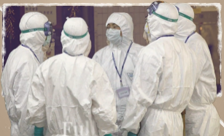

(2:48 - 3:54)
2003
Fought a disease called _________________ with his teammates
Hailed as an “____________ ____________” by Time Magazine for his contribution during the epidemic

(2:10 - 2:30)
2004
Awarded ______________ Bauhinia Star

(5:56 - 6:41)
2021
Planned to incorporate _________________
_________________ in practice of medicine

Part 2: Choose the best answer by circling the correct letter.

1. | When Professor Sung was a secondary student, he was interested in Biology because ______________________.
 | (A) he met fantastic Biology teachers
 | (B) he could do dissections of animals
 | (C) he was always the best in Biology exams
 | (D) he always found some rare species on the lawn

2. | Professor Sung is not just a doctor. He has been ______________.
 | (A) a teacher of a university
 | (B) a researcher of a university
 | (C) a teacher and a researcher of a university
 | (D) a teacher, a researcher and the vice chancellor of a university

3. | What is Professor Sung most proud of in his professional career?  He is most proud of ________________.
 | - getting rid of all the challenges in his professional career
 | - doing a lot of dissections of earthworms, rats and insects
 | - becoming a doctor and looking after patients
 | - having a deep understanding of people’s digestive systems

4. | Professor Sung said, “Challenge means that you go into uncharted waters.”  What does the phrase “uncharted waters” mean?  It means _________________.
 | - a situation which is completely new to you
 | - a situation in which you feel safe and comfortable
 | - a place where you meet marine life
 | - a place where you get an infectious disease

5. | According to Professor Sung, what qualities does a person need to be a doctor?  - be passionate about surgery  - be caring and kind to patients  - be diligent and work very hard  - be very smart with an IQ of 130
 | - (i) &(ii)
 | - (ii) & (iii)
 | - (i), (ii) & (iv)
 | - (ii), (iii) & (iv)
Post-viewing Activity
(Worksheet 3)
Part 1: (a) After watching the interview, what do you think about Professor Sung?
In each of the following moments, choose 1 or 2 adjective(s) that best describe(s) his personality traits, look for the clues and note them down in the spaces provided.
caring empathetic diligent determined

Moments | Personality traits | Clues
1.
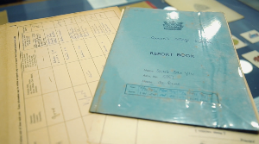

Secondary school life
(0:11 – 1:38)

2.

Working as a doctor
(1:58 – 2:48)
(4:38 – 5:07)

(b) Which of the following types of love best match the above moments?
Write the letter(s) in the heart provided. Each option can be used
more than once.
A. Love Our Country | D. Love Myself
B. Love the Community | E. Love Learning
C. Love Our Family and Friends | F. Love Nature
Part 2: An Introduction to Sayings of Wisdom (SOW)
A saying of wisdom (SOW) can be a proverb/quote or a line from a text. Study the following selected SOW and match them with the relevant type of love. The first one has been done for you as an example.

 | SOW |  |  |  | Types of Love
 | He loves his country best who strives to make it best.  (Robert G. Ingersoll) | • |  | • | Love Our Country
 | Life isn’t about finding yourself. Life is about creating yourself. (George Bernard Shaw) | • |  | • | Love the Community
 | The richness I achieve comes from nature, the source of my inspiration.  (Claude Monet) | • |  | • | Love Our Family and Friends
 | The noblest pleasure is the joy of understanding. (Leonardo da Vinci) | • |  | • | Love Myself
 | Walking with a friend in the dark is better than walking alone in the light. (Helen Keller) | • |  | • | Love Learning
 | The best way to find yourself is to lose yourself in the service of others.  (Mahatma Gandhi) | • |  | • | Love Nature
Part 3: Discuss in groups. Which of the SOW in Part 2 best describes how Professor Sung fought against SARS in 2003? Watch the video from 2:53 to 3:54 again to find more clues.

What were the challenges that Professor Sung and his colleagues faced in the period? | As SARS was a/an infectious disease, Professor Sung and his colleagues felt uncomfortable to deal with it. It took time to know about the disease.  They needed to face difficult situations in months. Many doctors got the in the period.
Describe Professor Sung’s attitude when he was fighting against SARS with his colleagues. | ___________________________________________________  ___________________________________________________  ___________________________________________________  ___________________________________________________  ___________________________________________________
Which SOW in Part 2 best describes how Professor Sung fought against SARS? | ___________________________________________________  ___________________________________________________  ___________________________________________________  ___________________________________________________  ___________________________________________________
What have you learnt from Professor Sung? What do you want to say to him?
____________________________________________________________________________________________________________________________________________________________________________________________________________________________________________________________________________________________________________________________________
The “SOW in Love” Letter Writing Competition
(Worksheet 4)

Context:
You would like to enter the “SOW in Love” Letter Writing Competition to express your love and gratitude to someone or something in around 130 to 160 words. You need to write a letter with a SOW of your choice that echoes the overarching theme “In Love We Share, In Love We Grow” and/or the six sub-themes below. Then, you have to create a two-dimensional (2D) artwork for the letter.

Part 1: Understand the overarching theme and the sub-themes.

In Love We Share, In Love We Grow

Love Our Country
Embracing our national identity, affection for hometown, appreciation of Chinese culture and heritage

Love the Community
Fostering a harmonious and inclusive society, caring for your school and neighbours, respecting diversity

Love Our Family and Friends
Filial piety and reverence for ancestors, responsibility and commitment to the family, friendship

Love Learning
Being inquisitive and reflective, a drive to apply and experiment with knowledge, lifelong learning
Love Myself
Personal growth, self-management, leading a healthy lifestyle

Love Nature
Biodiversity conservation, animal protection, green living

Can you suggest other things that we can do to express our love in different dimensions?
Part 2: Introduction to the Creative Use of English
- Literary devices
- We can use different literary devices such as alliteration, metaphor, personification and simile to describe people and feelings more vividly.
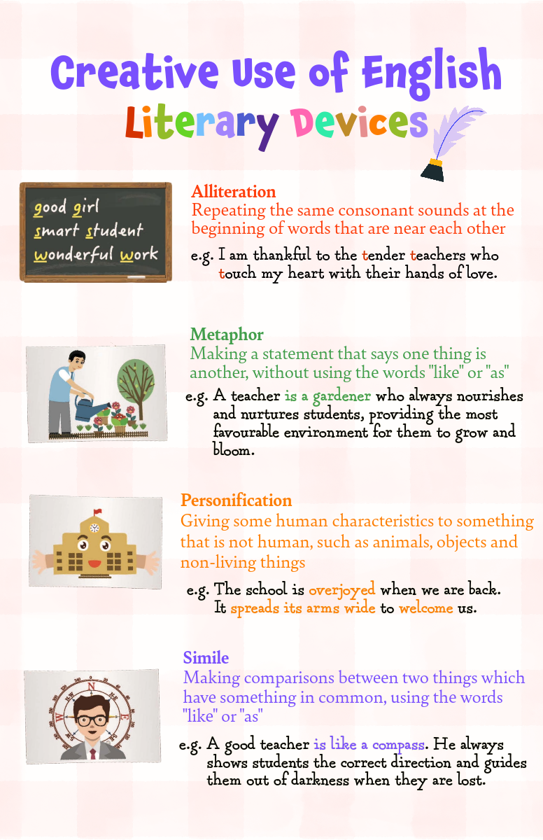

- Read the sentences below and identify the types of literary devices. Write the correct letters (A-D) in the boxes. Underline the words or phrases that feature the use of literary devices. The first one has been done for you as an example.

A. alliteration | B. metaphor | C. personification | D. simile

Sentences | Literary devices
e.g. You are a diligent doctor who has been determined to develop different therapies to heal the sick people over decades. | A
- When I was about to leave the hospital, I saw the flowers in the garden dancing happily to the rhythm of the breeze, celebrating my speedy recovery.

- You are the guardian angel of our community, who always gives us insightful advice on how to combat the disease.

- Doctor Chan is like a bee. He never rests for a moment.

- Choose one of the literary devices to write about someone or something you love. Tick the chosen literary device.
alliteration | metaphor | personification | simile

Part 2: Introduction to the Creative Use of English
- The “Showing Not Telling” technique
- Instead of stating your feelings directly in the letter, you can show your feelings through your actions. Read the poster below to learn different actions to express feelings.
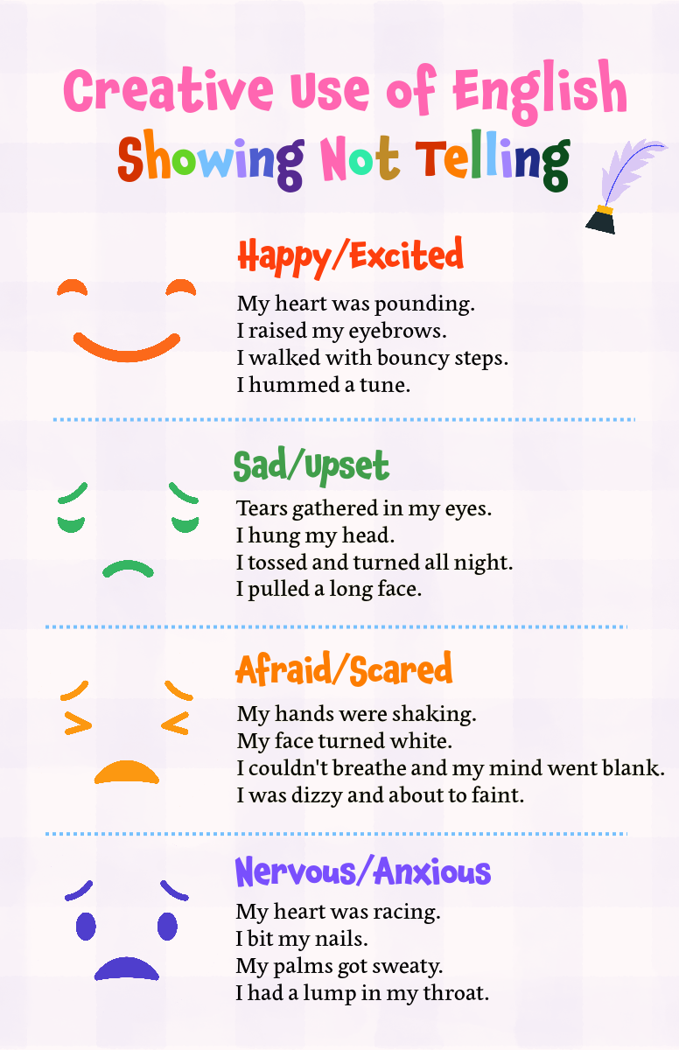

- Read the text below and rewrite the underlined parts to show feelings through actions. You can make reference to the poster “Showing Not Telling” in Part 2b(i).

 | Text | Rewritten version to show feelings through actions
e.g. | Last Sunday, I played with my friends in the park. Suddenly, my stomach was in knots. I was upset. I could not play with them anymore because it was so painful. | Last Sunday, I played with my friends in the park. Suddenly, my stomach was in knots. Tears gathered in my eyes. I could not play with them anymore because it was so painful.
1. | My parents sent me to hospital immediately. A doctor told my parents that I needed to have surgery. I was scared. | My parents sent me to hospital immediately. A doctor told my parents that I needed to have surgery.
2. | My parents could not give any responses to the doctor and they were anxious. The doctor comforted them and said that everything should be fine. | My parents could not give any responses to the doctor and  _______________________________.  The doctor comforted them and said that everything should be fine.
3. | Finally, the surgery was successful. My parents and I were thankful to the doctor and his team. They are my guardian angels for health. I am so excited because I have recovered from my illness. I can play with my friends very soon. | Finally, the surgery was successful. My parents and I were thankful to the doctor and his team. They are my guardian angels for health. _________  ________________________________  because I have recovered from my illness. I can play with my friends very soon.

Part 3: Analyse the key features of a letter to an alma mater and the language used
Mary would like to join the “SOW in Love” Letter Writing Competition. After watching the video about Professor Sung, she thought of her primary school life in the past. As a primary school graduate, she would like to write a letter to express her love and gratitude to her alma mater. Read her letter and complete (i) and (ii).
- Identify the key features of the letter and fill in the box with a correct letter.
- Saying of Wisdom (SOW) | - Greeting | - Writer’s experience
- Closing and  writer’s name | - Purpose of the letter | - Reflections that connect the SOW and personal experiences

- Underline the creative use of English in blue (i.e. literary devices / the “Showing Not Telling” technique).
Text features
Dear Alma Mater,

I am writing to express my heartfelt gratitude to you for my amazing primary school years.

It feels like it was only yesterday when I first entered the campus with bouncy steps. You took good care of me to ensure my emotional and social well-being. You also made every effort to nurture my love for learning. The teachers were like caring gardeners planting seeds of knowledge in my mind. I was encouraged to explore new concepts and broaden my horizons. The library was a wonderful place too.

I share the same view with Leonardo da Vinci’s saying “The noblest pleasure is the joy of understanding.” Because of your profound influence, I really enjoy learning and I am ready to overcome the challenges ahead.

Thank you once again, Alma Mater, for the invaluable lessons you bestowed on me. I will cherish the time we shared together and seize opportunities to contribute to society to make you proud.

Love,
Mary

of a letter

Part 4: (a) Think of someone (e.g. a character in a short story, your future self) or something (e.g. your school, the environment) you would like to write about. Based on the details in Parts 1- 3, organise your ideas using the graphic organiser below.
Continue your writing on p.42
Parts of the letter | Details
Greeting  - Who do you write the letter to? | Dear _____________________________,
Purpose of the letter  - Why do you write the letter?  - What do you think about the person or the thing you love?  Use the simple present tense to state the purpose of the letter and describe facts about the person or the thing you love. | __________________________________  __________________________________  __________________________________  __________________________________  __________________________________  __________________________________  __________________________________
Writer’s experience  - What was the most memorable experience you had with the person or the thing you love?  - What did you say to each other?  - What did you think about the experience?  Use the simple past tense to describe the experience.  Use the literary devices to describe the person or the thing you love and/or the “Showing Not Telling” technique to describe your feelings through actions. | __________________________________  __________________________________  __________________________________  __________________________________  __________________________________  __________________________________  __________________________________  __________________________________  __________________________________
Sayings of Wisdom (SOW)  - What is the SOW that connects with your experience?  - Which sub-theme does it belong to?  Use the simple present tense to describe the SOW. | __________________________________  __________________________________  __________________________________  __________________________________  __________________________________  __________________________________
Reflections that connect the SOW and the experience  - How are your experience and reflections connected with the SOW?  - What have you learnt from the person or the thing you love?  Use the simple present tense to describe the connection between the SOW and the experience, and your reflections. | __________________________________  __________________________________  __________________________________  __________________________________  __________________________________  __________________________________  __________________________________  __________________________________  __________________________________  __________________________________
Closing and writer’s name  Use “Best”, “Cheers” or “Love” to end the letter. | __________________________________  __________________________________  __________________________________  __________________________________  __________________________________  __________________________________  __________________________________

Part 4: (b) Use the ideas in the graphic organiser on pp.41-42 to write a letter to express your love and gratitude to someone or something with a SOW of your choice in around 130-160 words.

Part 4: (c) Create a 2D artwork to enhance conveyance of meaning and visual
representation of the letter.

Part 4: (d) Check your writing with the self-assessment checklist below.
Self-assessment Checklist
Assessment criteria |  | My performance  (Colour the smileys)
Content
1. | I can give a proper greeting at the beginning and a closing at the end of the letter.
2. | I can write about a memorable experience I had with the person or the thing one I love.
3. | I can share a SOW and connect it with my reflections.
Language
4. | I can use the simple present tense to describe facts.
5. | I can use the simple past tense to describe the memorable experience with the person or the thing I love.
6. | I can use different literary devices (e.g. personification, metaphor, simile) to write about the person and the thing I love.
7. | I can use the “Showing Not Telling” technique to describe feelings through actions.
Organisation
8. | I can put ideas into appropriate paragraphs.
Design of the letter
9. | I can create a 2D artwork to enhance conveyance of meaning and visual representation of the letter.

Suggested Answers
(Worksheet 1)
Pre-viewing Activity
(Accept any reasonable answers.)

- What did Professor Sung usually do for his patients?
- Why did Professor Sung want to be a doctor?
(Accept any reasonable answers.)
He wanted to take care of sick people.
He was interested in investigating different diseases.
(Accept any reasonable answers.)
He checked their digestive systems, stomachs or intestines for them.

- Apart from being a doctor, what else did Professor Sung do? Did he enjoy his jobs? Why?
- What was Professor Sung’s biggest challenge in his career as a doctor?

(Accept any reasonable answers.)
(Accept any reasonable answers.)
He had to deal with an unknown disease in 2003 and face difficult situations.
He was also a teacher of medical students at university. He enjoyed his jobs because he could cure his patients and share his experiences with his students.

While-viewing Activity
(Worksheet 2)
Part 1
Professor Sung Jao Yiu Joseph

(0:11 - 2:24)
Education:
1971-1978
- Studied at ________________________________

1984
- Graduated from a ______________ school

Queen’s College

medical

Work, achievements and challenges
(1:59 - 2:24)
1984
Started working as a doctor in the
____________________________________________________________________

Prince of Wales Hospital
2002
(2:10 - 2:30)
Achieved a ___________________ _________________ of using antibiotics to cure H. Pylori infection and treat peptic ulcer diseases
groundbreaking
discovery

(2:48 - 3:54)
2003

Fought a disease called _________________ with his teammates
Hailed as an “____________ ____________” by Time Magazine for his contribution during the epidemic
SARS

hero
Asian
(2:10 - 2:30)
2004
Awarded ______________ Bauhinia Star

2021
(5:56 - 6:41)
Silver

Planned to incorporate _________________
_________________ in practice of medicine
artificial
intelligence

Part 2
- B 2. D 3. C 4. A 5. B

Post-viewing Activity
(Worksheet 3)
Part 1
(Accept any reasonable answers.)

Moments | Personality traits | Clues
1.  Secondary school life  (0:11 – 1:38)  E | diligent | Professor Sung worked hard to improve his academic performance gradually from Form 1 to Form 5. He was actively engaged in his favourite subjects, i.e. Physics and Biology.
2.  Working as a doctor  (1:58 – 2:48)  B, E  (4:38 – 5:07) | caring/  empathetic/  diligent/  determined/ | - Professor Sung said he was most proud of being a doctor and taking care of the poor and the sick.  - He was sensitive to the needs of his patients.  - He thought it was important to work hard and learn every day.  - He made efforts to do research on the use of antibiotics to cure H. Pylori infection and treat peptic ulcer diseases.

Part 2
 | SOW | Types of Love
2. | Life isn’t about finding yourself. Life is about creating yourself. (George Bernard Shaw) | Love Myself
3. | The richness I achieve comes from nature, the source of my inspiration. (Claude Monet) | Love Nature
4. | The noblest pleasure is the joy of understanding.  (Leonardo da Vinci) | Love Learning
5. | Walking with a friend in the dark is better than walking alone in the light. (Helen Keller) | Love Our Family and Friends
6. | The best way to find yourself is to lose yourself in the service of others. (Mahatma Gandhi) | Love the Community

Part 3
(Accept any reasonable answers.)
What were the challenges that  Professor Sung and his colleagues faced in the period? | As SARS was a/an mysterious/unknown infectious disease, Professor Sung and his colleagues felt uncomfortable to deal with it. It took time to know about the disease.  They needed to face difficult situations in six months. Many doctors got the illness in the period.
Describe Professor Sung’s attitude when he was fighting  against SARS with his colleagues. | Professor Sung was positive and optimistic. He showed support and care to his colleagues by working with them in the ward together during the outbreak of the epidemic.
Which SOW in Part 2 best describes how Professor Sung fought against SARS? | The best way to find yourself is to lose yourself in the service of others. (Mahatma Gandhi)
(Worksheet 4)
The “SOW in Love” Letter Writing Competition
Part 2 (a) (ii)
Sentences | Literary devices
- When I was about to leave the hospital, I saw the flowers in the garden dancing happily to the rhythm of the breeze, celebrating my speedy recovery. | C
- You are the guardian angel of our community, who always gives us insightful advice on how to combat the disease. | B
- Doctor Chan is like a bee. He never rests for a moment. | D

Part 2 (b) (ii)
(Accept any reasonable answers.)
 | Text | Rewritten version to show feelings through actions
1. | My parents sent me to hospital immediately. A doctor told my parents that I needed to have surgery. I was scared. | My parents sent me to hospital immediately. A doctor told my parents that I needed to have surgery. I couldn’t breathe and my mind went blank.
2. | My parents could not give any responses to the doctor and they were anxious. The doctor comforted them and said that everything should be fine. | My parents could not give any responses to the doctor and their palms got sweaty. The doctor comforted them and said that everything should be fine.
3. | Finally, the surgery was successful. My parents and I were thankful to the doctor and his team. They are my guardian angels for health. I am so excited because I have recovered from my illness. I can play with my friends very soon. | Finally, the surgery was successful. My parents and I were thankful to the doctor and his team. They are my guardian angels for health. I walk with bouncy steps because I have recovered from my illness. I can play with my friends very soon.

Part 3
Text features
Dear Alma Mater,

I am writing to express my heartfelt gratitude to you for my amazing primary school years.

It feels like it was only yesterday when I first entered the campus with bouncy steps. You took good care of me to ensure my emotional and social well-being. You also made every effort to nurture my love for learning. The teachers were like caring gardeners planting seeds of knowledge in my mind. I was encouraged to explore new concepts and broaden my horizons. The library was a wonderful place too.

I share the same view with Leonardo da Vinci’s saying “The noblest pleasure is the joy of understanding.” Because of your profound influence, I really enjoy learning and I am ready to overcome the challenges ahead.

Thank you once again, Alma Mater, for the invaluable lessons you bestowed on me. I will cherish the time we shared together and seize opportunities to contribute to society to make you proud.

Love,
Mary

of a letter
B

The “Showing not Telling” technique
Personification
E

Personification
simile
C

A

F

D

